Emerging Technologies Report
Tinotenda Mhedziso

Table of Contents
Introduction 1
Literature Review 2
Historical Context 2
Current Context 2
Future Context 2
Methodology 3
Discussion & Analysis 3
Technical Foundations 3
Industry Adoption 4
Applications & Case Studies 4
Challenges & Limitations 4
Recommendations 4
Conclusion 4
References 5
Appendices 6

Introduction
This document serves as a practical demonstration of my proficiency in structuring a comprehensive academic paper. The primary objective is to facilitate an assessment of my analytical, organizational, and technical skills, allowing the supervising lecturer, Dr. Kevin Kativu, to precisely identify both strengths and areas requiring further development.
As this submission is intended solely as a practice extract and not a formal, publishable work, please note the following:
All content, including data and synthesized figures, is used strictly for the purpose of practical experience and skills demonstration. Language and data used throughout the document is adapted from ChatGPT and Gemini.
This paper is structured to achieve the following aims:
Define the selected emerging technology, providing a clear overview of its core components and function.
Analyse the scope and application of the technology across various sectors.
Explain its relevance and significance within the context of the module's learning objectives.
Gaps between text flow are present as I wanted to mimic the hierarchy of a formal document.

Literature Review
An academic analysis of the chosen technology. I often try follow an academic tone while maintaining connection with the reader. The current text here is informal as these are just notes.

Historical Context
What was it like then.

Current Context
What is it like now.

Future Context
What could it be like.

Methodology
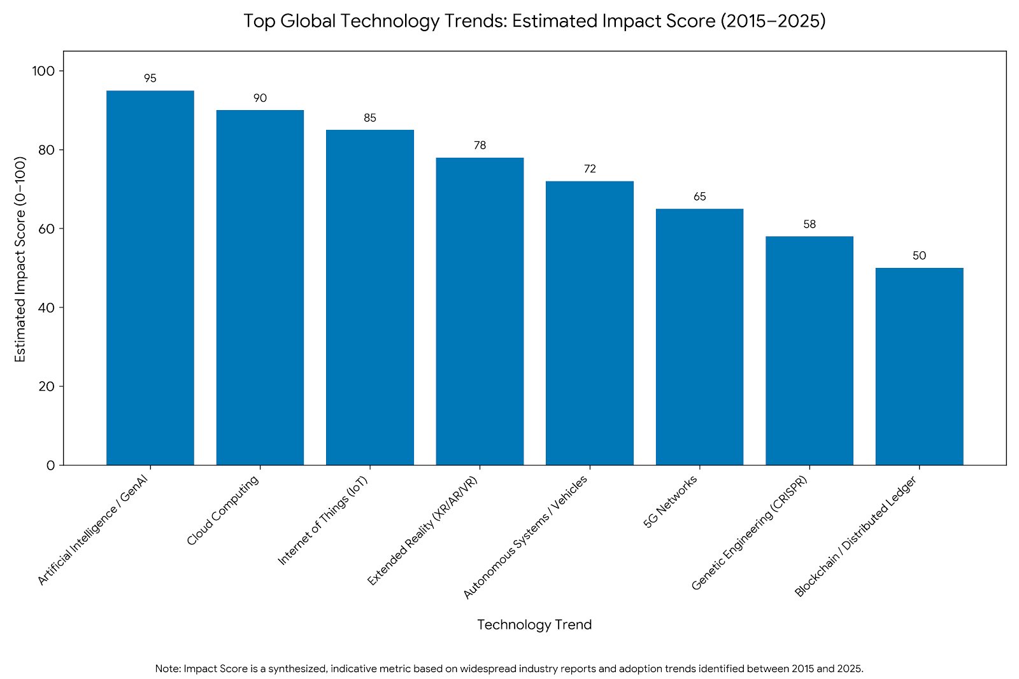
This is my overall review.

Figure 1

Discussion & Analysis
According to Figure 1, the last decade has been dominated by the rapid acceleration of Artificial Intelligence. AI has outpaced other technological fields in terms of market impact (McKinsey & Company, 2025). The graph on the Top Global Technology trends demonstrates how AI has:
- Overwhelming Dominance: Artificial Intelligence (AI) and Generative AI register the highest Estimated Impact Score (95/100), clearly positioning it as the most significant and transformative technology trend of the 2015–2025 decade.
- Enabler of Other Trends: AI's high score is reinforced by its direct relationship with other high-impact trends, as its functionality is dependent on and improves through Cloud Computing (90) and the massive data streams provided by the Internet of Things (IoT) (85).
- Recent Acceleration: While AI has been a trend for years, its recent surge, particularly the rise of Generative AI (since late 2022), is a critical factor in its peak score, driving unparalleled investment and rapid enterprise adoption.
- Gap Analysis: The score of 95 for AI shows a notable impact gap of 17 points over the next tier of highly visual/interactive technologies, such as Extended Reality (XR/AR/VR) (78), indicating a prioritization of foundational, data-processing systems over pure user-interface technologies in the decade's overall impact.
- Long-Term Disruption: The high impact score suggests that AI has transitioned from a niche development to a foundational layer across multiple industries, affecting everything from logistics and manufacturing (often overlapping with Autonomous Systems) to consumer service and creative production.

Technical Foundations
The technical aspects of the emerging technology. How I would reference a book: Research has shown that market disruption is inevitable (Chang, 2024).
How I would cite a digital document(pdf): The latest economic forecasts suggest moderate growth (Global Trade Alliance, 2025).

Industry Adoption

Applications & Case Studies

Challenges & Limitations

Recommendations

Conclusion
And that’s the end of the document. Usually I have a 200 – 250 worded conclusion.

References

Chang, S. (2024). Digital transformation in emerging markets: A guide to platform strategy. Wiley Press.
Global Trade Alliance. (2025). Annual report on global logistics and sustainability (2024-2025). https://www.gta.org/reports/annual-logistics-report-2025.pdf
Google. (2025). Gemini Advanced (Model update 1.5) [Large language model]. https://gemini.google.com/
McKinsey & Company. (2025). The top trends in tech: Technology trends outlook 2025. https://www.mckinsey.com/capabilities/mckinsey-digital/our-insights/the-top-trends-in-tech
OpenAI. (2024). ChatGPT (GPT-5 version) [Large language model]. https://chat.openai.com/

Appendices

Appendix A

Supplementary Data and Methodology for Figure 1
The following appendix provides the underlying synthetic data and clarification on the methodology used to generate the Top Global Technology Trends: Estimated Impact Score (2015–2025) bar graph presented in Figure 1.

Table A.1: Synthetic Data for Estimated Technology Impact
This table outlines the Estimated Impact Score used for graphing, which is a metric synthesized from an analysis of multiple industry reports (e.g., Gartner, McKinsey, WEF) concerning technology adoption, investment, and long-term disruptive potential between 2015 and 2025.

